These are unprecedented times and we all know that managing cash will be a major focus for all businesses.
As part of the standard Contracts functionality Workbench includes a Cashflow capability. For those who use it, the focus is usually to predict when the Revenue will be raised, or Costs incurred. The focus is usually not a cash / bank view.
There are also various groups of transactions outside of Workbench which will impact on a cash / bank view and these include at least the following.
- The pace at which Debtors will pay your unreceipted current invoices.
- The pace at which Debtors will pay future invoices.
- The pace at which you will pay outstanding Subcontractors & Creditors, a value that Workbench views as included in the Actual Cost.
- The pace at which you will pay future Subcontractors & Creditors, again a cost that Workbench will view as an Actual Cost.
- You may have Retentions to receive or release over the coming months.
- Potential non-cash costs like Time Recharges also look like Actual Costs to a project but are more generally accounted for as cash via some sort of Corporate Overheads entity.
- There will be other forms of transactions that need to be accommodated.
An increasing number of Workbench users are successfully using SharperLight. However, they may be unaware that the extraction capability can be incorporated in Excel.
Once in Excel, each of the bullet points above could be included in those same Excel Worksheets to enhance the base data from Workbench, to produce a more cash-based view of each project. See the full-page example below of a working model that has been developed to demonstrate how this could work for your business.
This screenshot then shows how data from the individual project worksheets could use standard Excel functionality to provide a whole of business view and include information that doesn’t even exist in Workbench like Corporate Overheads.
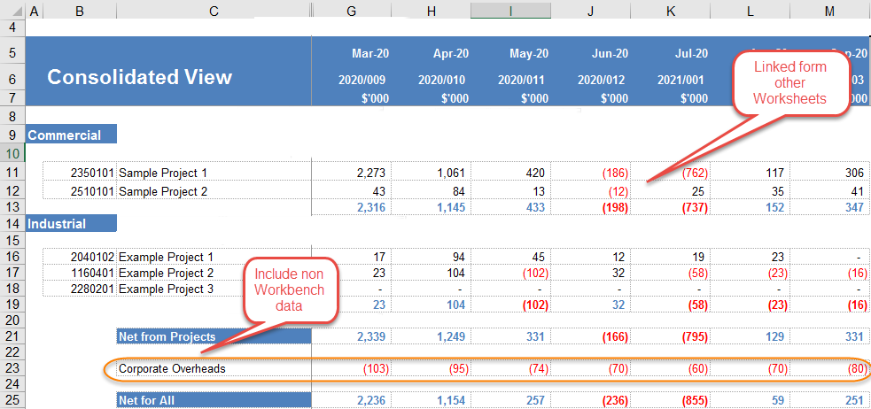
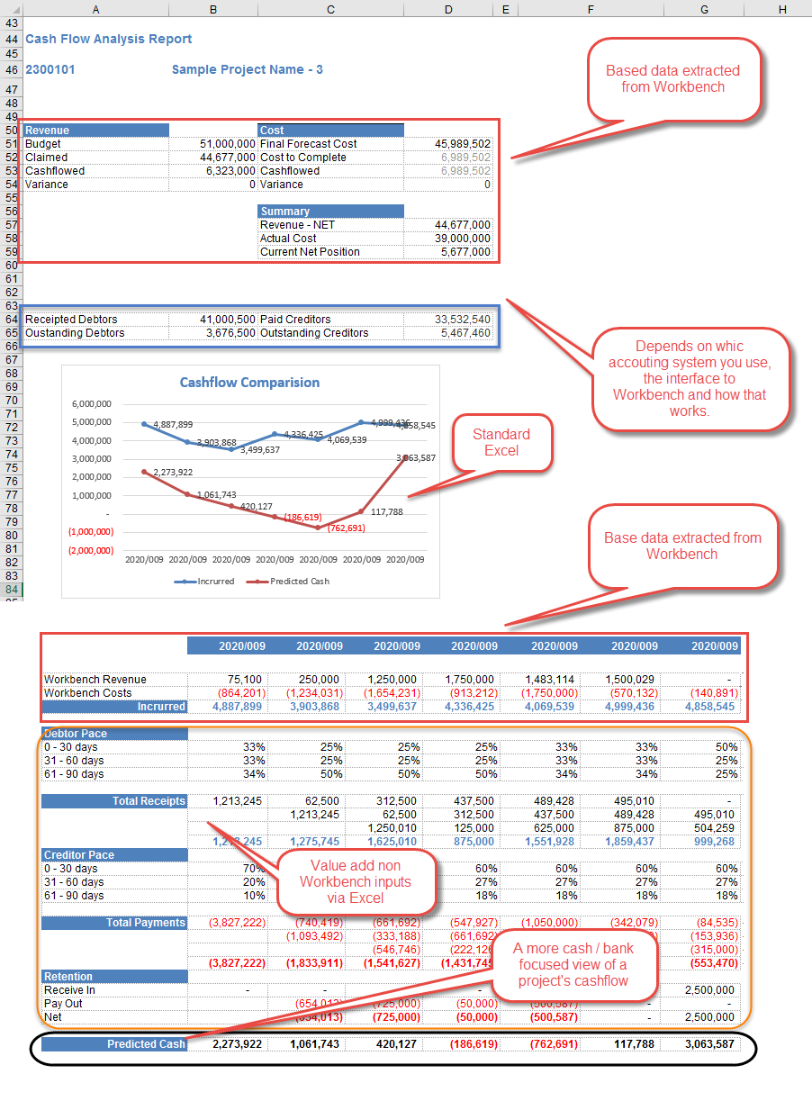
If this is a capability that you’re interested pursuing, or understanding more about, then please get in touch.

